

The value of a multi-agency approach to detect, analyse and disrupt illicit financial flows.
Mr Adam Coin
Chargé d’Affaires
Australian Embassy, Santiago Chile

_____________________

Introduction
Distinguished Guests, Ladies and Gentlemen
Firstly, may I congratulate Chile, Thailand and APEC partners for their far-sighted leadership in hosting this important conference.
Unfortunately colleagues from the Australian Attorney-General’s Department were not able to travel to Chile for this conference. While I am not an expert in this topic, this speech has been prepared by specialists. I would like to acknowledge and thank them, and can assist in making contact if you would like to follow-up on material in my presentation today.
The APEC Anti-Corruption and Transparency Experts Task Force is a global pioneer in recognising the importance of using anti-money laundering systems to tackle corruption and transnational crime.
The Task Force clearly recognised the value of removing the profit and incentive from corruption and crime by tracing and confiscating illicit financial flows — another key theme of this conference.
Today’s rapid technological developments are bitter-sweet.
They create new problems for effective law enforcement, but they also bring new opportunities to detect and successfully investigate corruption and transnational crime.
As corrupt officials and criminals exploit rapidly evolving technologies to conceal their evil deeds, intelligence analysts and investigators need new techniques and partnerships to sift and sort massive amounts of data to identify crime and support effective investigations.
This morning I would like to share with you what Australia has learned about promoting such cooperation and effectiveness:
- Firstly, I will briefly mention why this work, and this conference, is so important, particularly to reduce the harm caused by corruption and transnational crime.
- Secondly, I will describe the pivotal role of financial intelligence in detecting potentially corrupt transactions and other illicit financial flows.
- Finally, I will explain our efforts to achieve ‘fusion’ of our various intelligence and investigative resources to develop the clearest ‘big picture’ of serious organised crime and corruption.
- Why is disrupting corruption and transnational crime so important?
Global corruption harms various APEC security and development interests:
1st. Corruption worsens poverty and disease
- The poor suffer most from corruption, especially women and children. Corruption diverts scarce resources away from education, healthcare and poverty eradication.
- Corruption is also strongly correlated with child mortality.
2nd. Corruption undermines human rights
- Transparency International and the International Council on Human Rights consider the fight against corruption is central to the struggle for human rights, noting that:
“A government’s ability to respect, protect and fulfil human rights – social, cultural, political, economic and civil – will ultimately be defined by the level and systemic nature of corruption.”
3rd. Corruption inhibits sustainable development and economic growth
- In 2012, UN Secretary General Ban Ki Moon described the impact of corruption on development as “direct and devastating”.
- The World Bank has found corruption inhibits development and economic growth through many channels, including reduced foreign investment and higher costs for business.
- Conversely, the World Bank notes that countries which improve control of corruption can expect a significant long-term ‘governance dividend' of increasing incomes and reductions in poverty.
4th. Corruption accelerates climate change
- Corruption undermines environmental governance.
- For example, most deforestation in tropical timber producing countries is illegal and facilitated by corruption and transnational crime. Deforestation generates more greenhouse gas emissions than all forms of transport combined.
5th. Corruption facilitates criminal state capture and state failure
- The International Monetary Fund notes that while most types of corruption seek to change how existing laws, rules, or regulations are implemented, “state capture” refers to efforts to influence how those laws, rules, and regulations are formed and implemented.
- Corruption enables criminals to encode advantages for themselves in the legal and regulatory systems of the economy, at the expense of rule of law and legitimate enterprise.
Finally, corruption encourages criminal and violent extremist cooperation
- The international convergence of organised crime, violent extremism and corruption is mutually reinforcing.
- Assisted by corrupt officials, transnational criminal organisations and extremist groups are increasingly helping each other move products, money, weapons, personnel and goods, while profiting mutually from the transactions.

- The pivotal role of financial intelligence in detecting transnational crime and corruption
One of the most powerful strategies in the fight against corruption and transnational crime is financial intelligence.
However, the sophisticated use of financial intelligence to combat corruption is still developing.
Effective links are still being created between anti-corruption authorities and financial intelligence units.
To support this work, the Financial Action Task Force has published a range of guidance on the use of the FATF Recommendations to assist countries and businesses to combat the laundering of the proceeds of corruption.
APEC has shown great leadership here, and we express again our gratitude to Chile and Thailand and other APEC partners for their very productive work in recent years.
Such work is gaining ground outside the APEC region.
The G20 Anti-Corruption Action Plan welcomes the Financial Action Task Force’s revised standards, implementation of which will assist to prevent and detect the laundering of proceeds of corruption and other crimes.
Again, a core theme in these developments is to make effective use of financial intelligence.
I would like to share some insights from Australia’s experience in monitoring and analyzing financial intelligence.
The first lesson for us is the extraordinary growth in the number of international financial transactions.
Analysts and investigators have access to a massive and rapidly growing body of financial data — a situation shared by many APEC economies here today.
[SLIDE: GROWTH OF INTERNATIONAL FUNDS TRANSFER REPORTS]
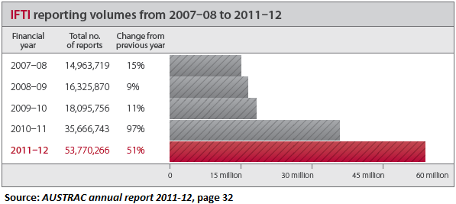
Over the past five years, reports of international funds transfers (to and from Australia) have grown from almost fifteen million in 2007-08 to almost fifty four million in 2011-12 — an increase of around 260 per cent.
This growth reflects the growing maturity of the transaction reporting regime, and the large number of reporting entities now covered by Australia’s anti-money laundering regime.
Mining this information yields significant intelligence and investigation benefits, as seen in the following case study.
[SLIDE: FOLLOWING THE INTERNATIONAL MONEY TRAIL]
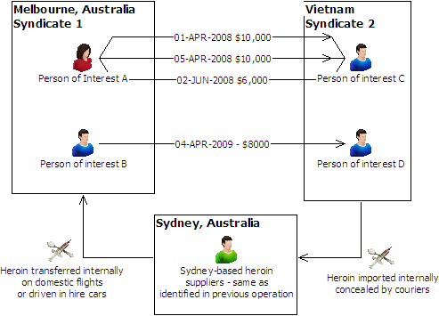
Thankfully, we do not need to delve into the details of the illicit drug network shown on the slide — it basically shows a criminal network operating between Australia and Vietnam.
Analysis of international money transfers enabled investigators to:
- Identify the principal controlling a number of crime syndicates
- Uncover other syndicate members previously unknown
- Discover links to other syndicates — an illicit “network of networks” — previously thought to be unrelated, and
- Reveal how the syndicates operated, in both Australia and Vietnam.
Another excellent benefit of analysing the vast number of international transactions is that it can reveal other networks not previously identified.
[SLIDE: FINANCIAL DATA MINING CAPACITY]
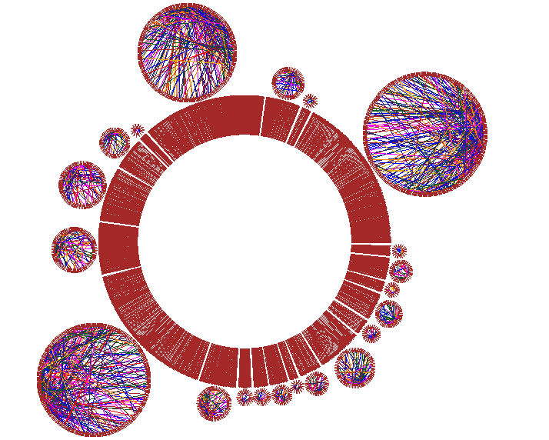
This slide illustrates modern financial data mining capacity.
The slide represents all international funds transfer instructions to a specific foreign region.
While it may look confusing, for an experienced data miner, this represents a wealth of information:
- To start with, we can see 21 networks (the smaller circles outside the big red circle) which the data miner and investigators could then analyse further
- Within the smaller circles, different coloured strands show the extent of financial ties between specific entities.
Such networks may be entirely legitimate, or they may reveal links of interest for analysts and investigators to examine further.
The key point is that sophisticated tools — such as geo-spatial and time-series analysis, or network analysis as demonstrated here — helps analysts and investigators to sift through the ‘noise’ of vast financial data to find leads for further analysis and investigation.
A modern financial intelligence unit (FIU) can provide a range of services to anti-corruption and law enforcement agencies. These services range from simple data descriptions to complex analysis, including:
- scalable link analysis and spatial analysis of geographical locations and interactions
- text mining to find themes and concepts in unstructured data, and
- modelling to develop rules to explain and predict behaviour.
- Integration or ‘fusion’ of intelligence and investigative resources to develop the big picture of serious organised crime and corruption.
Firstly, what do we mean by ‘fusion’?
In simple terms, the purpose of fusion is to help our policy and law enforcement agencies to see the bigger picture of organised and transnational crime.
The bigger picture can’t be seen if information and intelligence remains separated in multiple agencies.
Fusion is the process integrating and analysing those multiple sources.
Australia launched the fusion project in 2010.
So far, the project has informed the design of various initiatives, including the Counter-Terrorism Control Centre and the Criminal Assets Confiscation Taskforce. Plans are also underway to establish the Australian Cyber Security Centre.
To explain how the fusion concept works in practice, I will briefly describe the Australian Crime Commission Fusion Centre.
The Fusion Centre brings together specialists from different government agencies, and different levels of government, with access to multiple information and intelligence holdings.
The Fusion Centre includes staff from the national intelligence community, the Australian Crime Commission, the Australian Taxation Office, Australia’s financial intelligence unit (AUSTRAC), the national welfare agency (Centrelink), the Department of Immigration and Citizenship, and our state and territory law enforcement agencies.
Staff from these diverse agencies bring expertise in financial investigation, operational psychology, data-mining, statistical analysis, database management and architecture.
They put the pieces together from different agencies to produce a more comprehensive picture of criminal targets, risks, threats and vulnerabilities.
Although only established in 2010, we are already seeing the benefits of fusion.
For example, earlier this year, fusion intelligence detected a series of suspicious international transactions from Australia valued in excess of $A20 million. Intelligence also showed the use of false identifies and credit cards. Following this detection, Australian law enforcement agencies located two significant methylamphetamine laboratories.
Fusion has also paid dividends for the detection of international money laundering and the recovery of assets.
For example, in late 2012 fusion identified likely proceeds of crime in excess of $38 million being transferred to a foreign country. In another, significant money laundering involving profession facilitators was identified. These detections are now being investigated.
The second example I will briefly describe is the multi-agency Criminal Asset Confiscation Taskforce.
Established in 2011, the Taskforce is hosted and led by Australian Federal Police (AFP), and brings together the resources and networks of the Australian Crime Commission, and the Australian Taxation Office.
The primary objective is to attack the financial base of serious and organised crime.
It achieves this by removing the proceeds and instruments of crime, and importantly prevents the reinvestment of criminal profits into future crime.
Prosecutors work closely with the investigations teams, and are co-located in AFP offices around Australia.
The Australian Taxation Office provides financial analysis support through co-located officers.
With the involvement of the tax office, the Taskforce protects the public finances of Australia from local or international criminal abuse of the tax system.
Crime Commission staff assist target identification and provide advice on money-flows involving Australia.
The Taskforce ensures the resources and legislative mandate of each agency are fully utilised and enables the development of the most effective strategy for each individual case – whether by proceeds of crime action, tax remedies or other means.
The Taskforce has dramatically improved the investigation and restraint of proceeds of crime:
- $18.9 million was restrained in 2009/10, before the Taskforce was established
- with the benefit of the Taskforce, asset restraint more than doubled to $41.1 million in the following year (2010-11)
- almost $100 million was restrained in the 2011/12 financial year — an increase of around 425 per cent in three years.
Conclusion
To conclude, all APEC member economies stand to gain from cooperating to detect and disrupt the global flow of illicit funds, and to remove profit from corruption and transnational crime.
Australia appreciates the opportunity presented by this conference to further strengthen APEC’s leading role in this field, and applauds the initiative and hospitality of our conference hosts.
Thank you.

********

